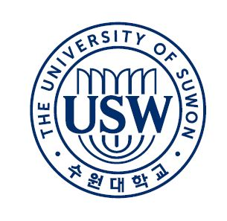**Korean Language&Culture Institute**

**Application Form**

|  |
| --- |
| **Attach**  **Photo**  **here** |

**등록학기(Term Applied for) 입학년도(Year)**

(* 최초 등록자는 최소 2학기 신청)

□봄(Spring) □여름(Summer) □가을(Fall) □겨울(Winter)

**이름 Name in Full** □남(Mr.) □여(Ms.)

|  |  |  |  |
| --- | --- | --- | --- |
| 한글(Korean) |  | 영문(English) |  |

* 여권의 이름과 동일하게 작성하세요. (Write the same name as the passport.)

**학생기본정보 Information of Student**

**\* 한국 입국 여부 Entry to Korea □ 예(Yes) □ 아니오(No)**

|  |  |  |  |
| --- | --- | --- | --- |
| **주소**  **Address** | 한국내 (In Korea) | | |
| 본국 (Homeland) | | |
| **전화번호**  **Telephone No.** | 본인 연락처 (Mobile Phone) | | |
| 비상전화 (Emergency contact)  관계(relationship) /이름(Name in Full) | | |
| **생년월일**  **Date of Birth** |  | **여권번호**  **Passport No.** |  |
| **국적**  **Nationality** |  | **비자종류**  **Type of VISA** |  |
| **전자우편주소**  **Email** |  | **토픽레벨**  **TOPIK Level** | □ No □ 1 □ 2 □ 3 □4 |
| **최종학력(학교명)**  **Last School Degree**  **(School name)** |  | **재학기간**  **Periods of Study** | **~** |
| **부모님 인적사항**  **Information of parents** | | | |
| **성명**  **Name** |  | **관계**  **Relationship** |  |
| **직장명**  **Workplace** |  | **연락처**  **Telephone** |  |

지원서 상에 표기된 모든 것은 사실입니다.

I herein state that all the information provided on the application is correct.

**20 년(Year) 월(Month) 일(Date)**

**지원자 서명 Applicant Signature**

**수원대학교 한국어·문화교육원장** 귀하

(Submitted to the President of the Korean Language&Culture Institute University of Suwon)